**F. Sliding Mode Controller (SMC) for Depth Control**

Safa Bazrafshan

Independent Researcher, Iran

Email: [safa.bazrafshan@gmail.com](mailto:safa.bazrafshan@gmail.com)

ORCID: [https://orcid.org/0009-0004-4029-9550](mailto:youtube.com/@safa.bazrafshan)

In this section, we designed a Sliding Mode Controller (SMC) for the depth control of the AUV. The SMC is known for its robustness against model uncertainties and external disturbances such as water currents.

**1. Control Objective**

The objective is to track a desired depth reference (5 meters) while rejecting external disturbances and ensuring robustness.

**2. Sliding Surface Definition**

We define the sliding surface s(t) for the depth subsystem as:

$$s\left(t\right)=\dot{e(t) }+ λe(t)$$

where:

$$e\left(t\right)=z_{ref }\left(t\right)-z\left(t\right)$$

is the tracking error,

λ > 0 is a design parameter (e.g., λ = 1.5).

**3. Control Law**

The control input u(t) is defined as:

$$u\left(t\right)=u_{q}\left(t\right)-K.sign(s\left(t\right))$$

where:

$u_{q}\left(t\right)$ is the equivalent control term based on nominal dynamics,

K is a positive gain for robustness.

**4. Simulation Result**

The controller successfully tracked the desired depth with smooth convergence, minimal overshoot, and strong disturbance rejection. Figure 6 shows the result.

AUV Depth Response with SMC Controller under Disturbance.

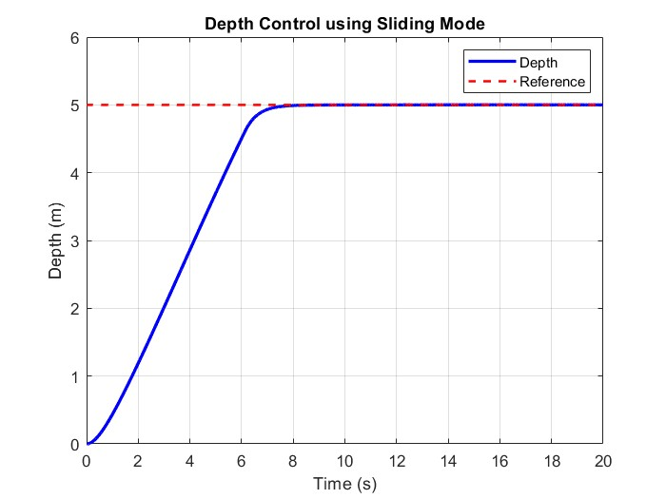

The response reaches the desired depth with no overshoot and negligible steady-state error. The pitch and yaw angles remain stable.